SIMATS ENGINEERING
ASSESSMENT TOOL-1
COURSE NAME: Artificial Intelligence COURSE CODE: CSA1701

COURSE OUTCOME COVERED
CO2: Experiment search and game-solving techniques such as Greedy Search, A*, CSP, Minimax, and Alpha-Beta pruning with heuristic functions for solving complex AI problems efficiently. (BL3)
Assessment Tool Weightage: 50%
Duration: 30 Minutes
QUESTIONS: 20 Total Marks:20
Annexure A MCQ Test

Code of Conduct:
I ALAN ALDRIN EA(192411023)(Name / Reg No) certify that this submission is my original work and that I have adhered to the guidelines specified for this assessment.
I understand that any violation of academic integrity rules will result in disciplinary action.
Signature of the student:
ALAN ALDRIN EA
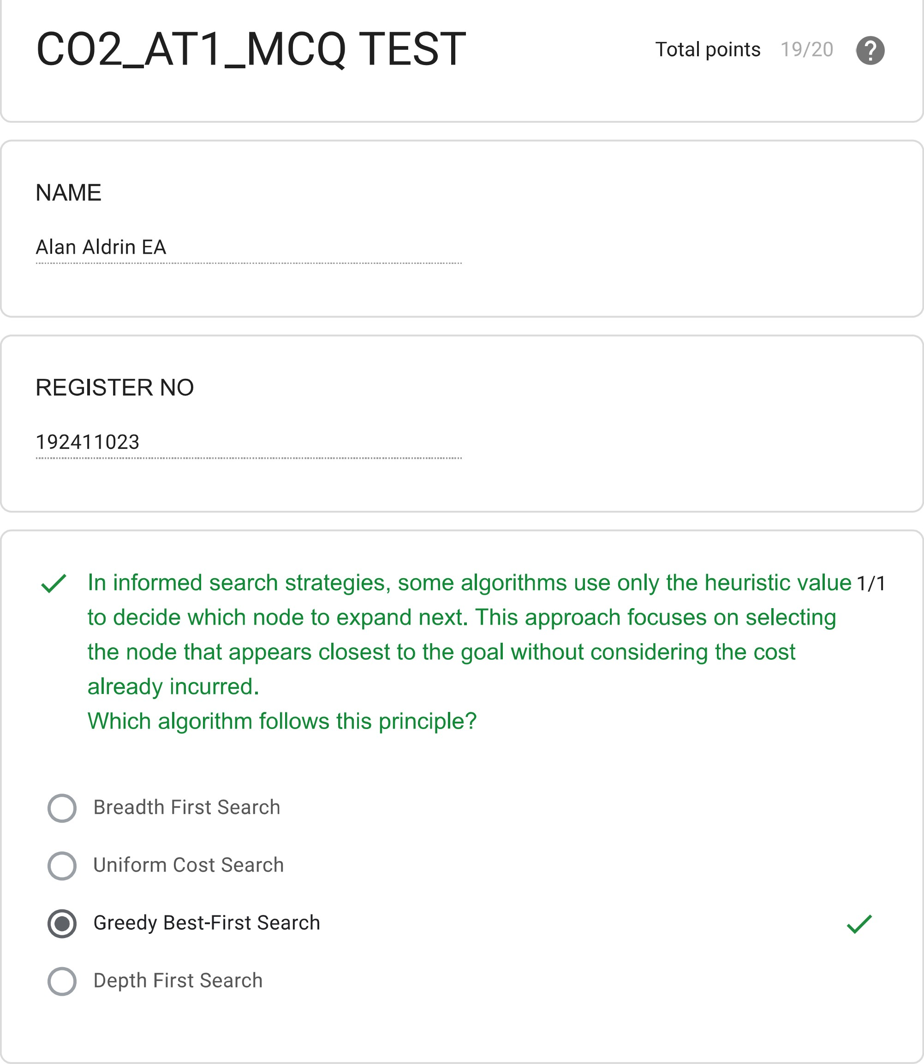
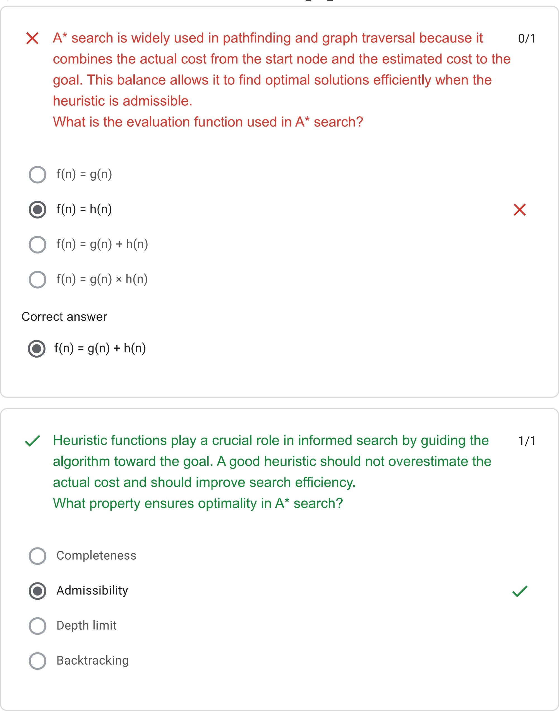
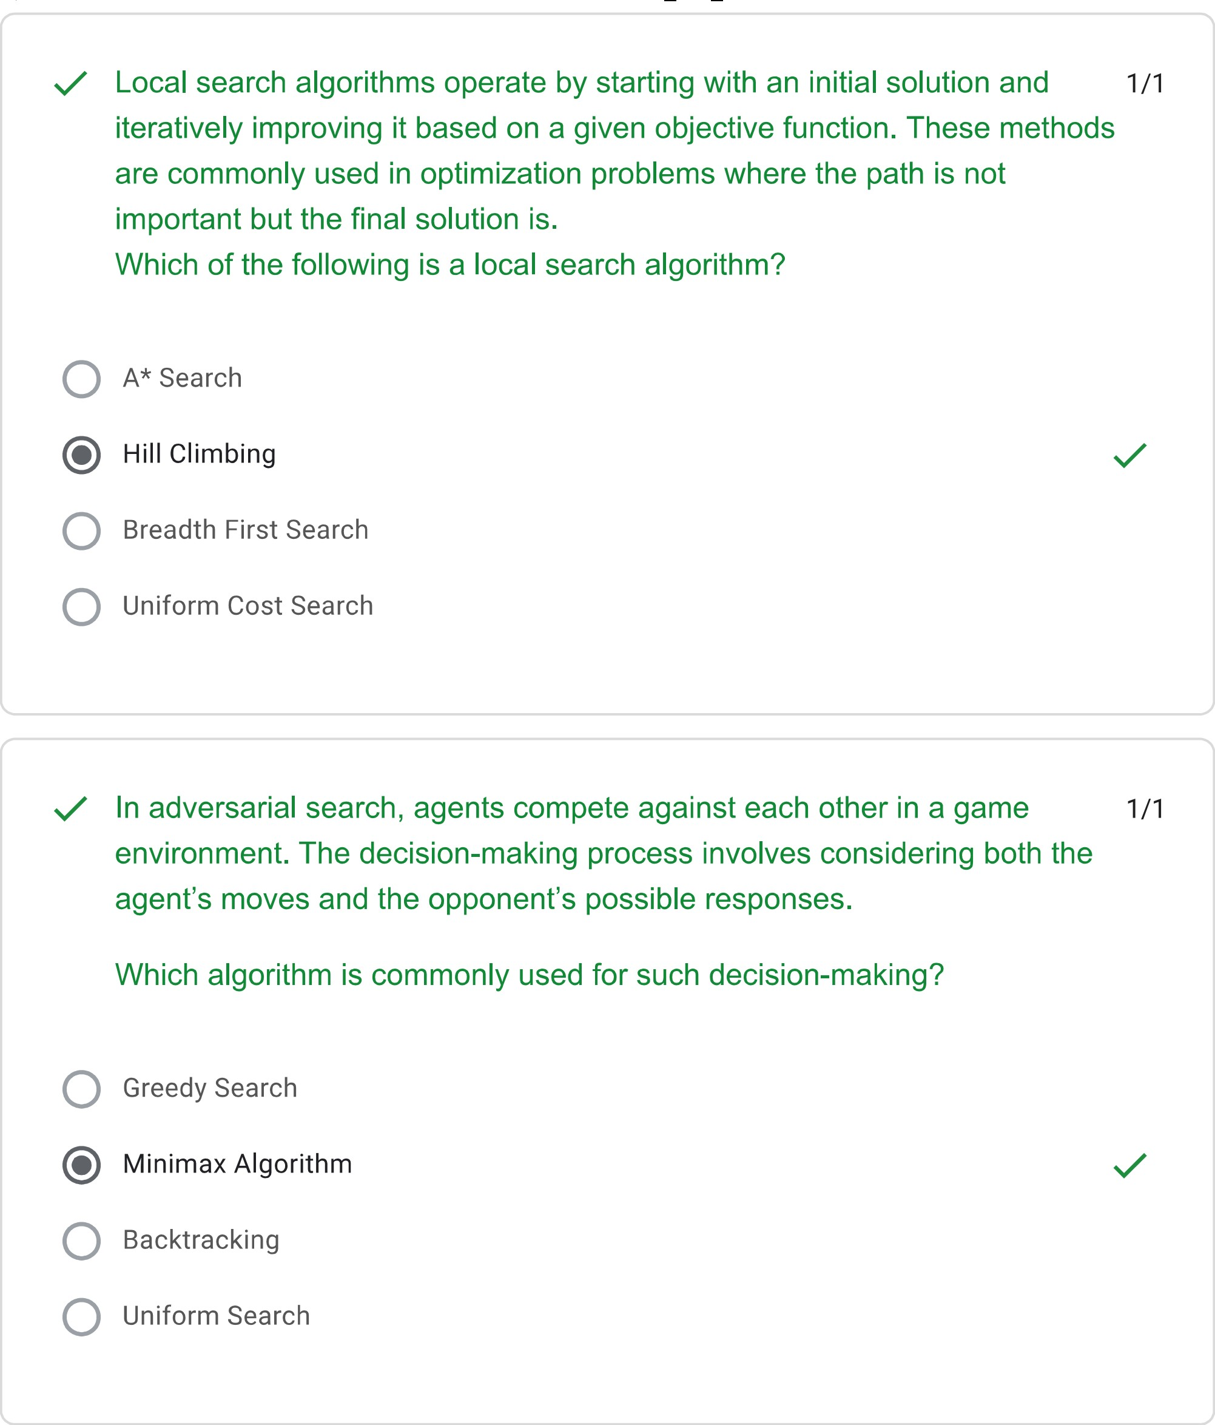

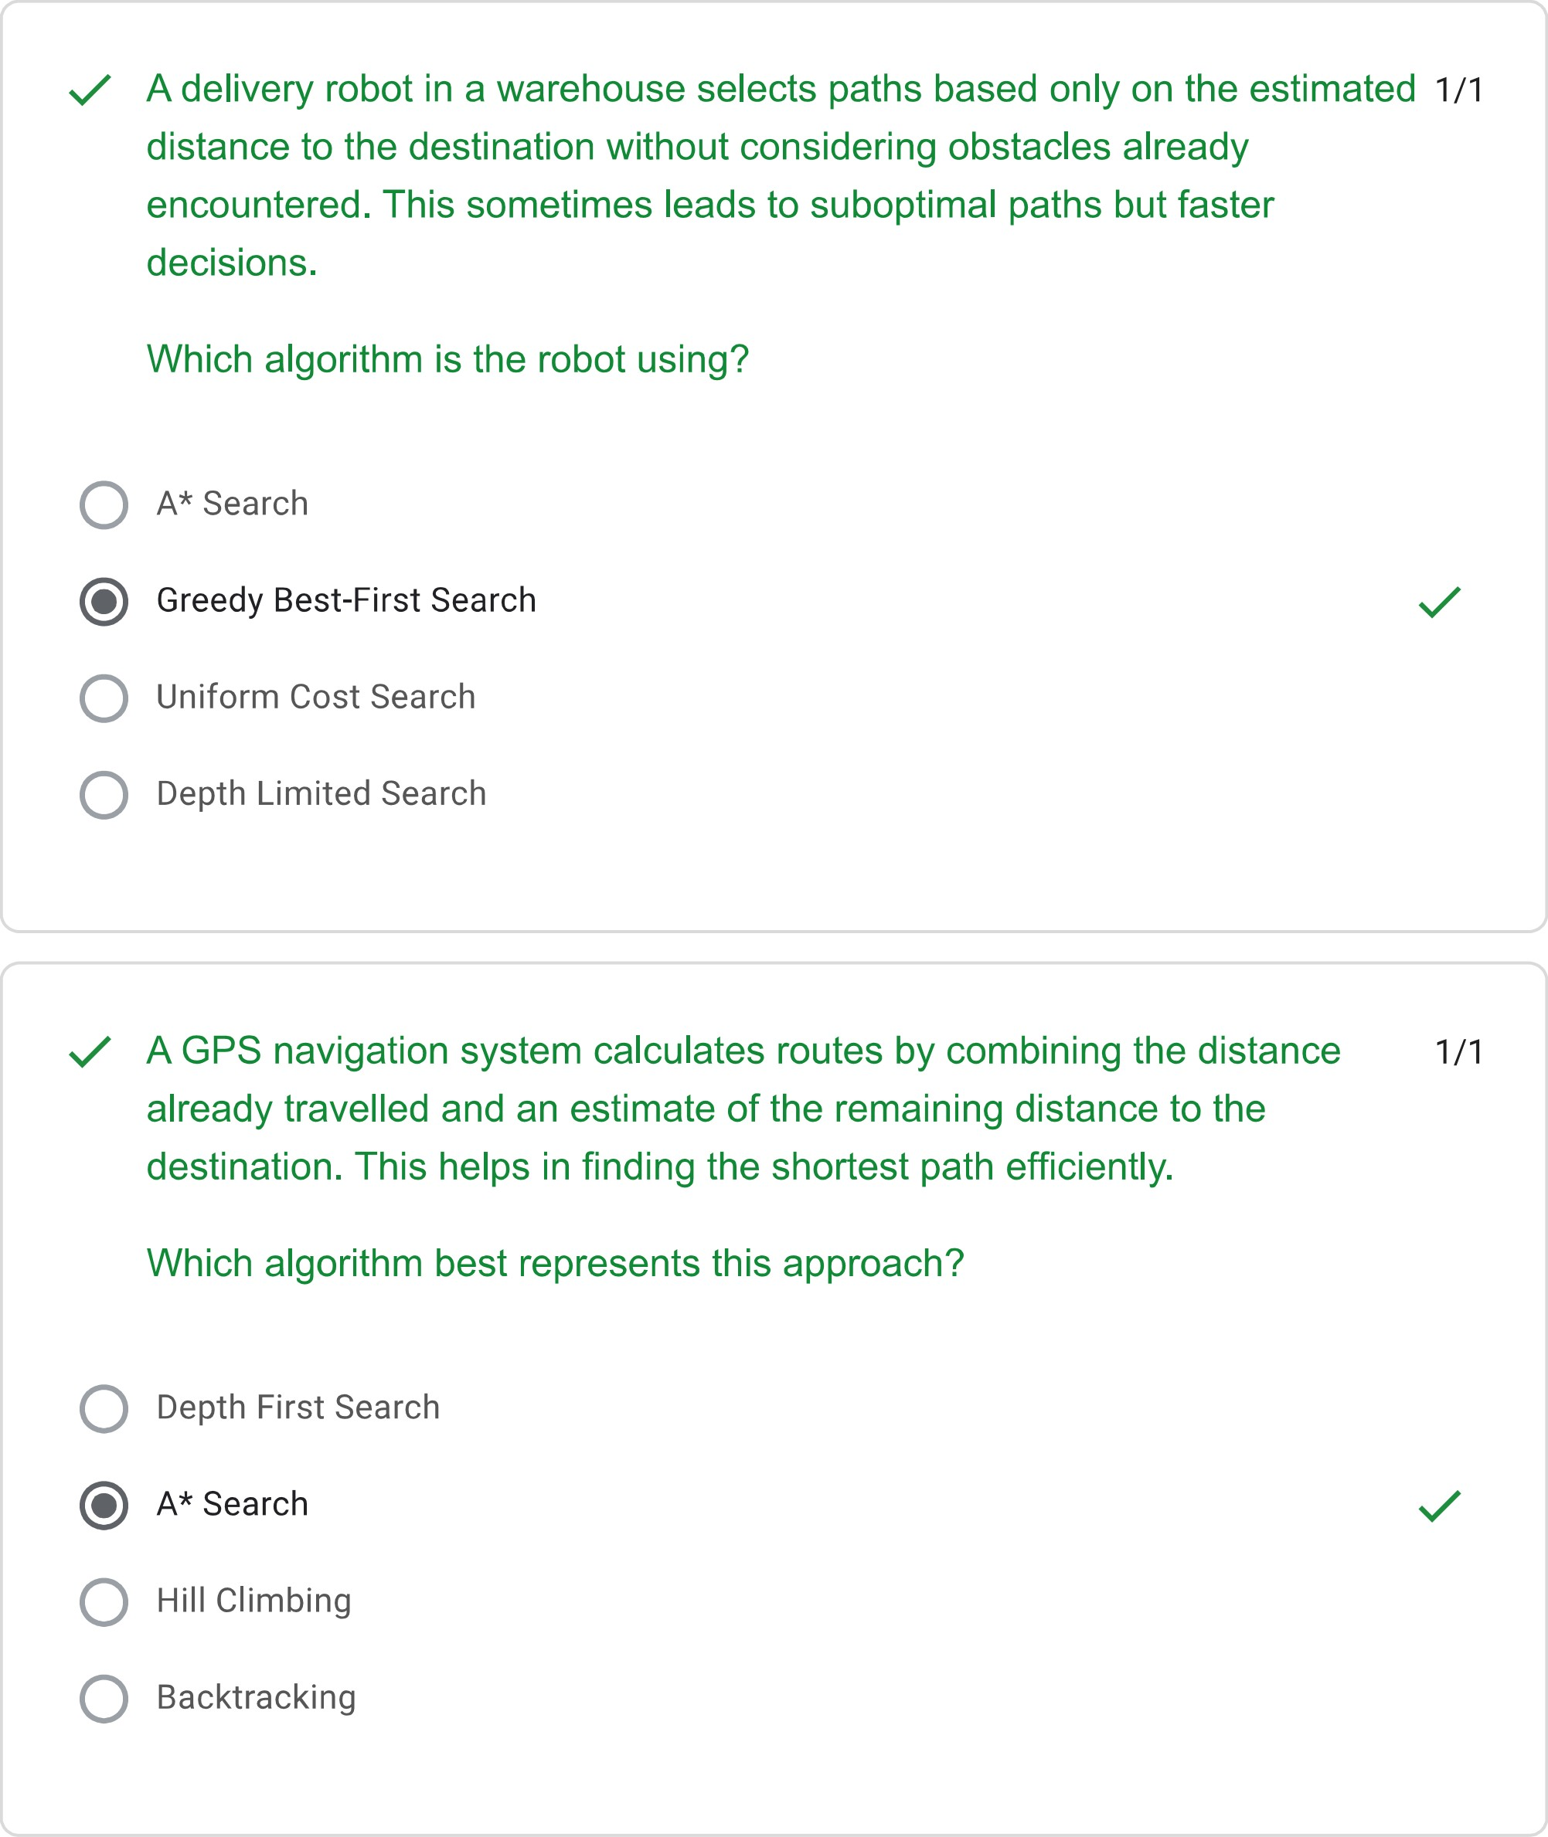
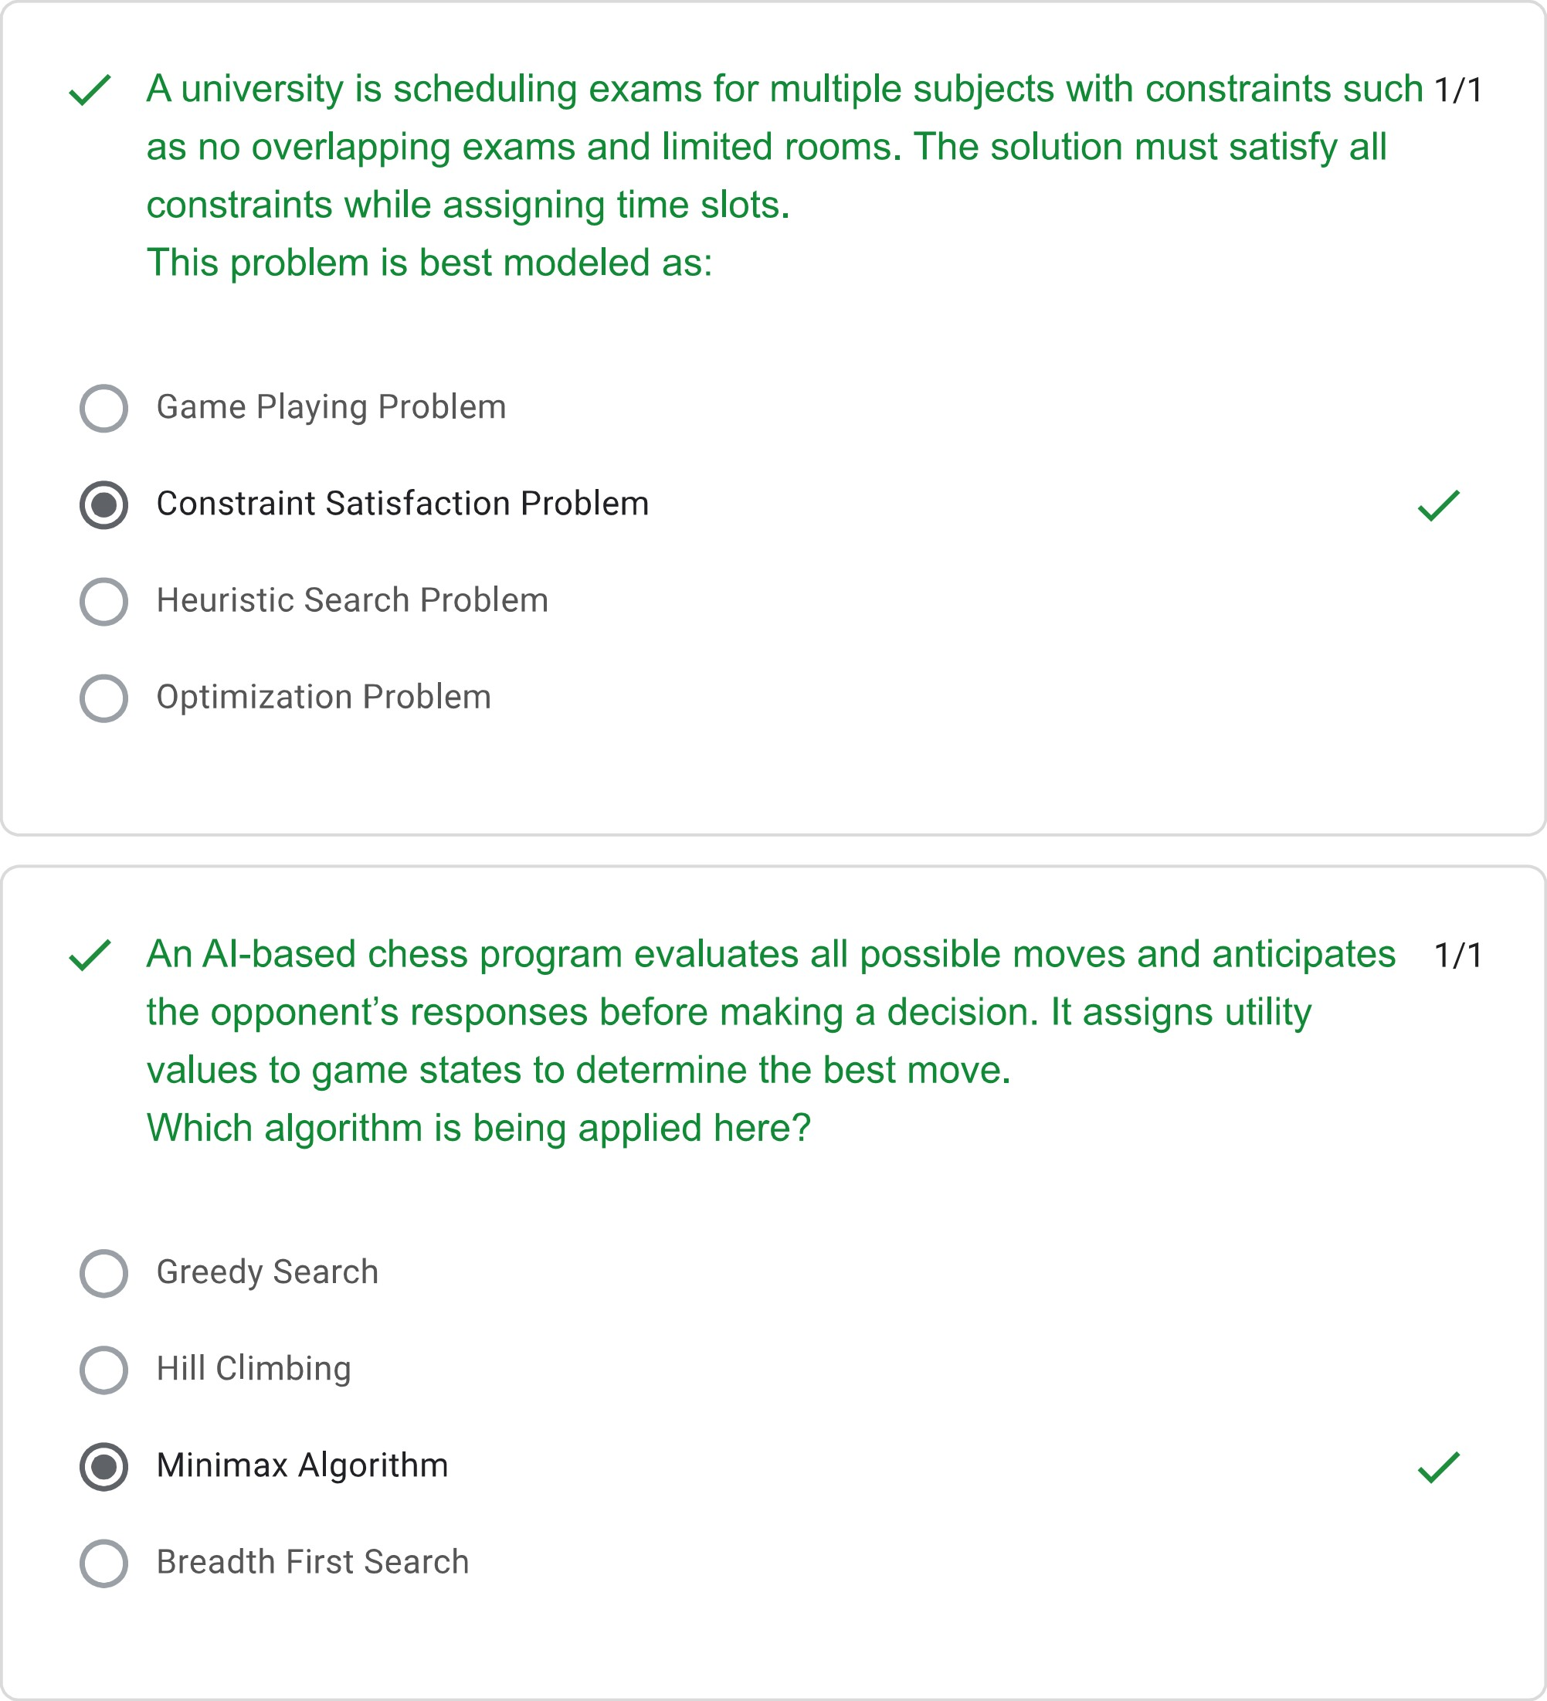
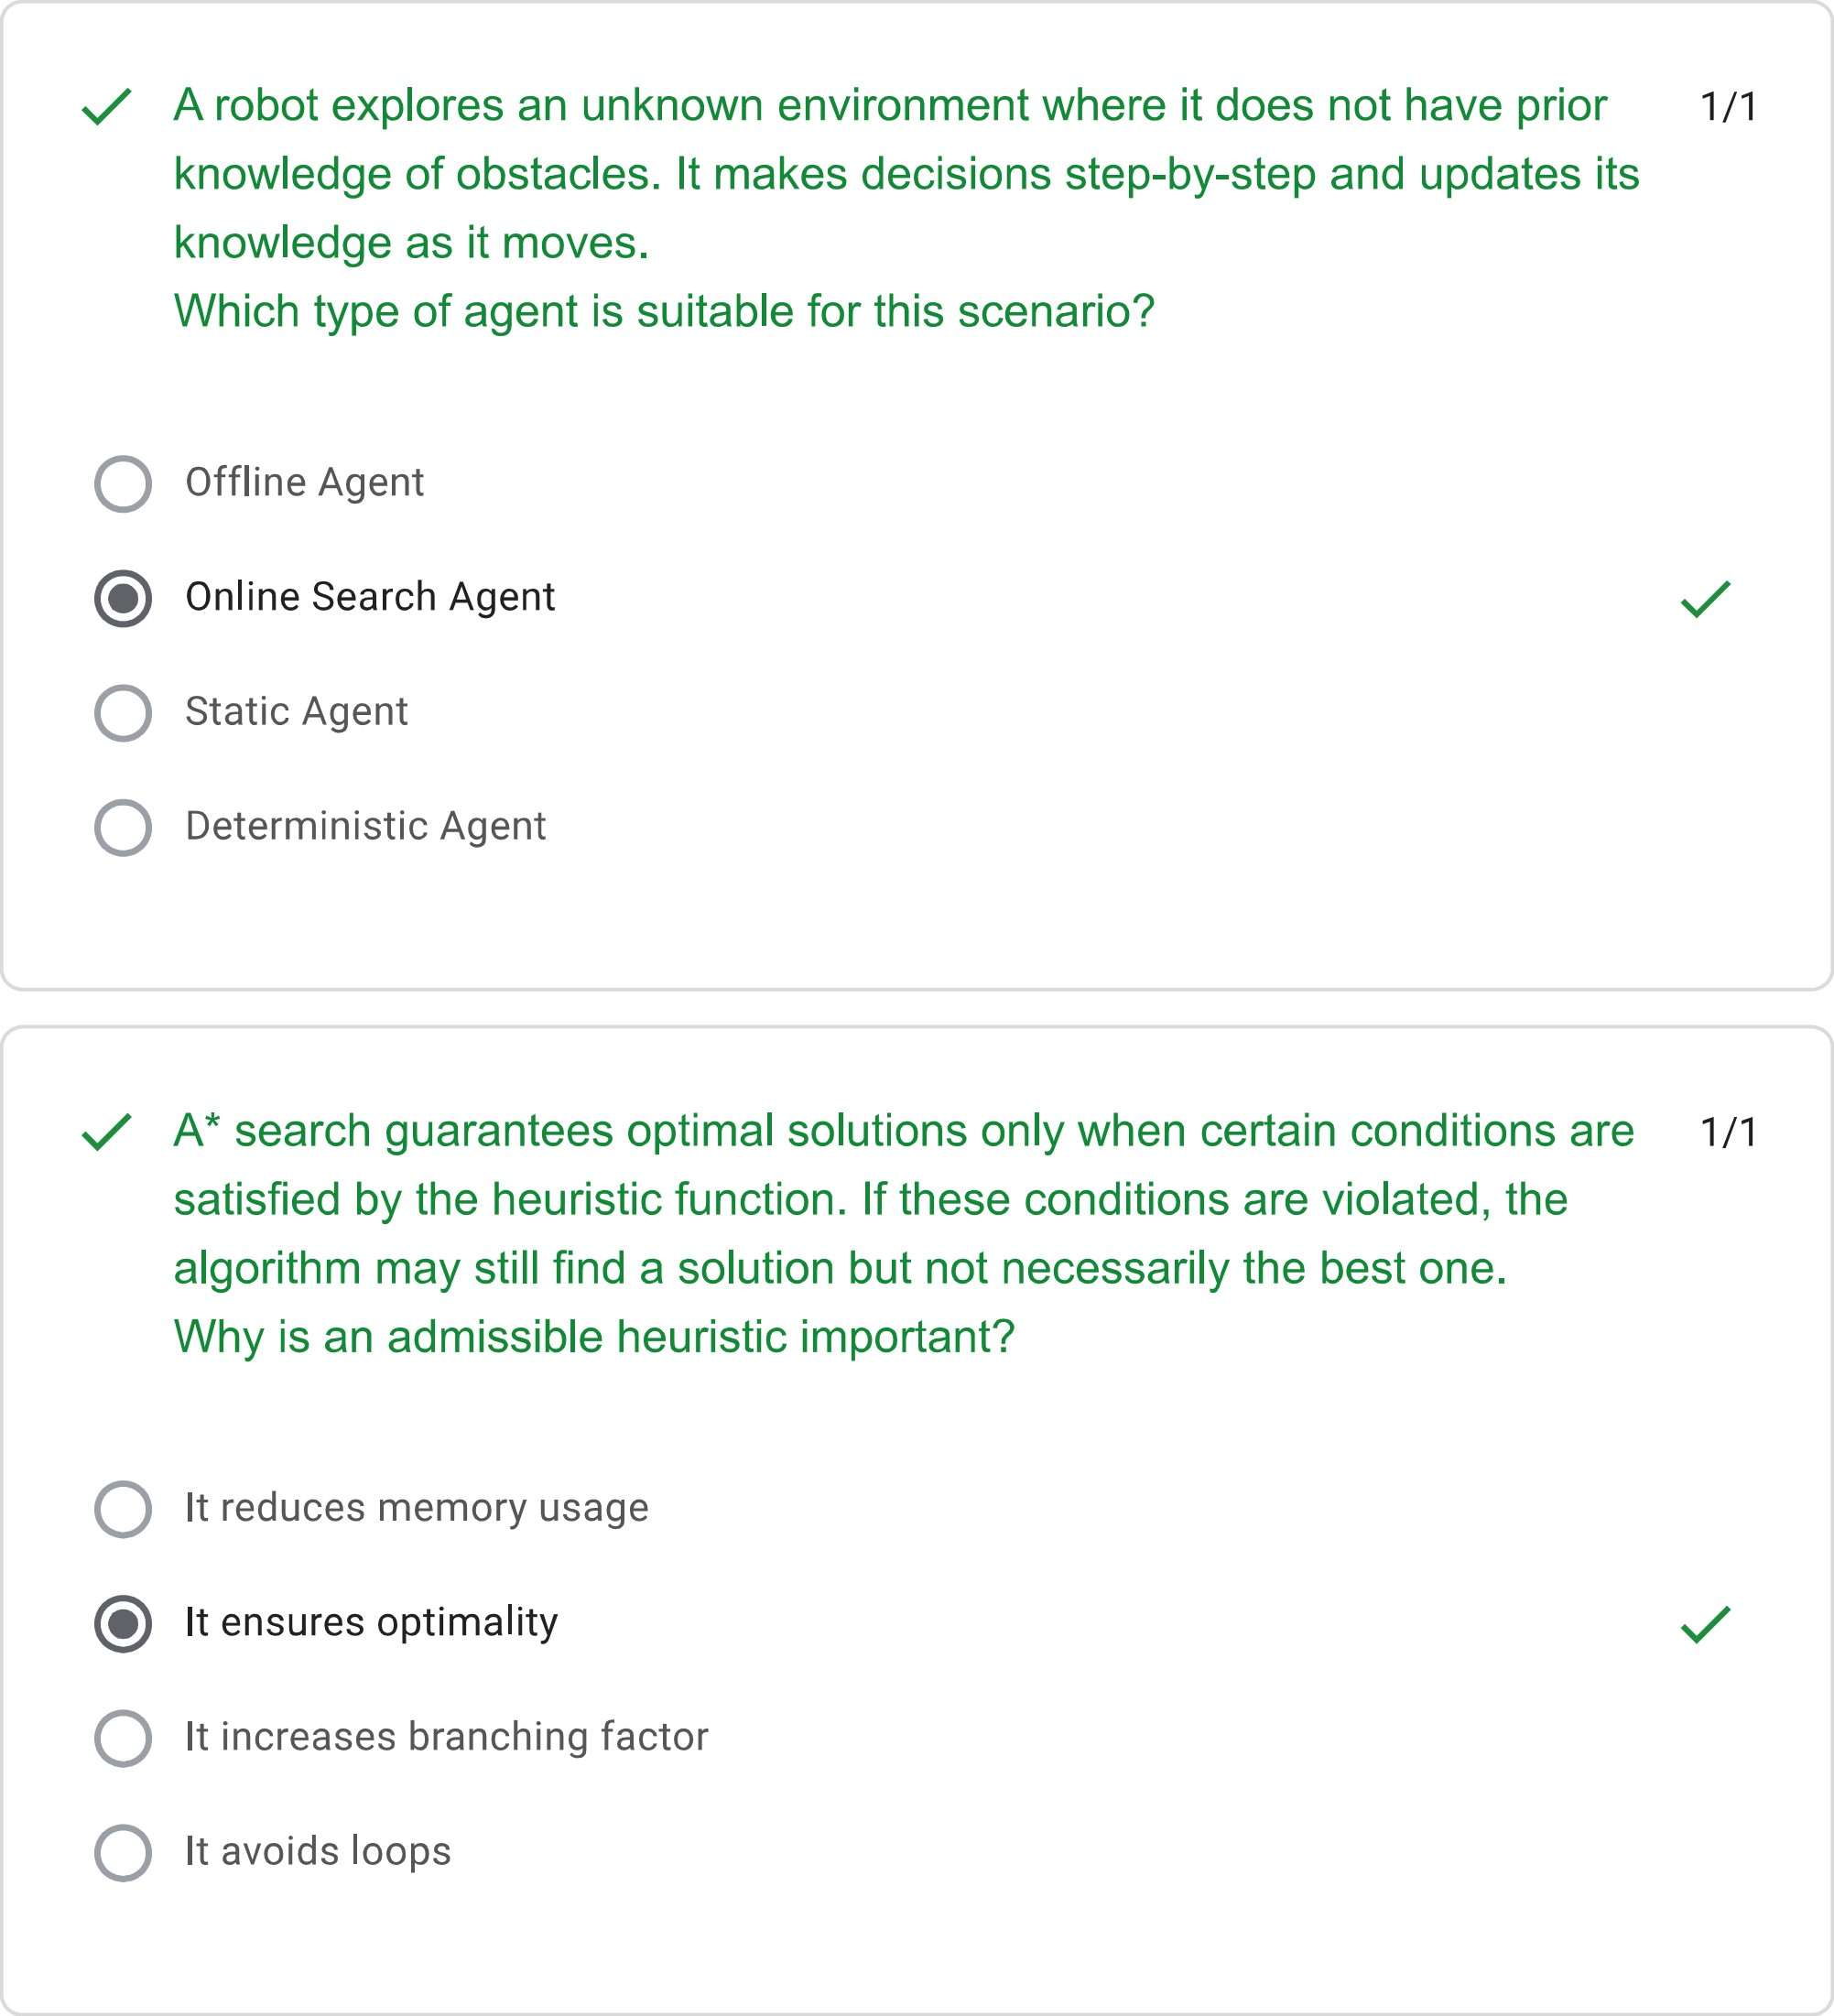

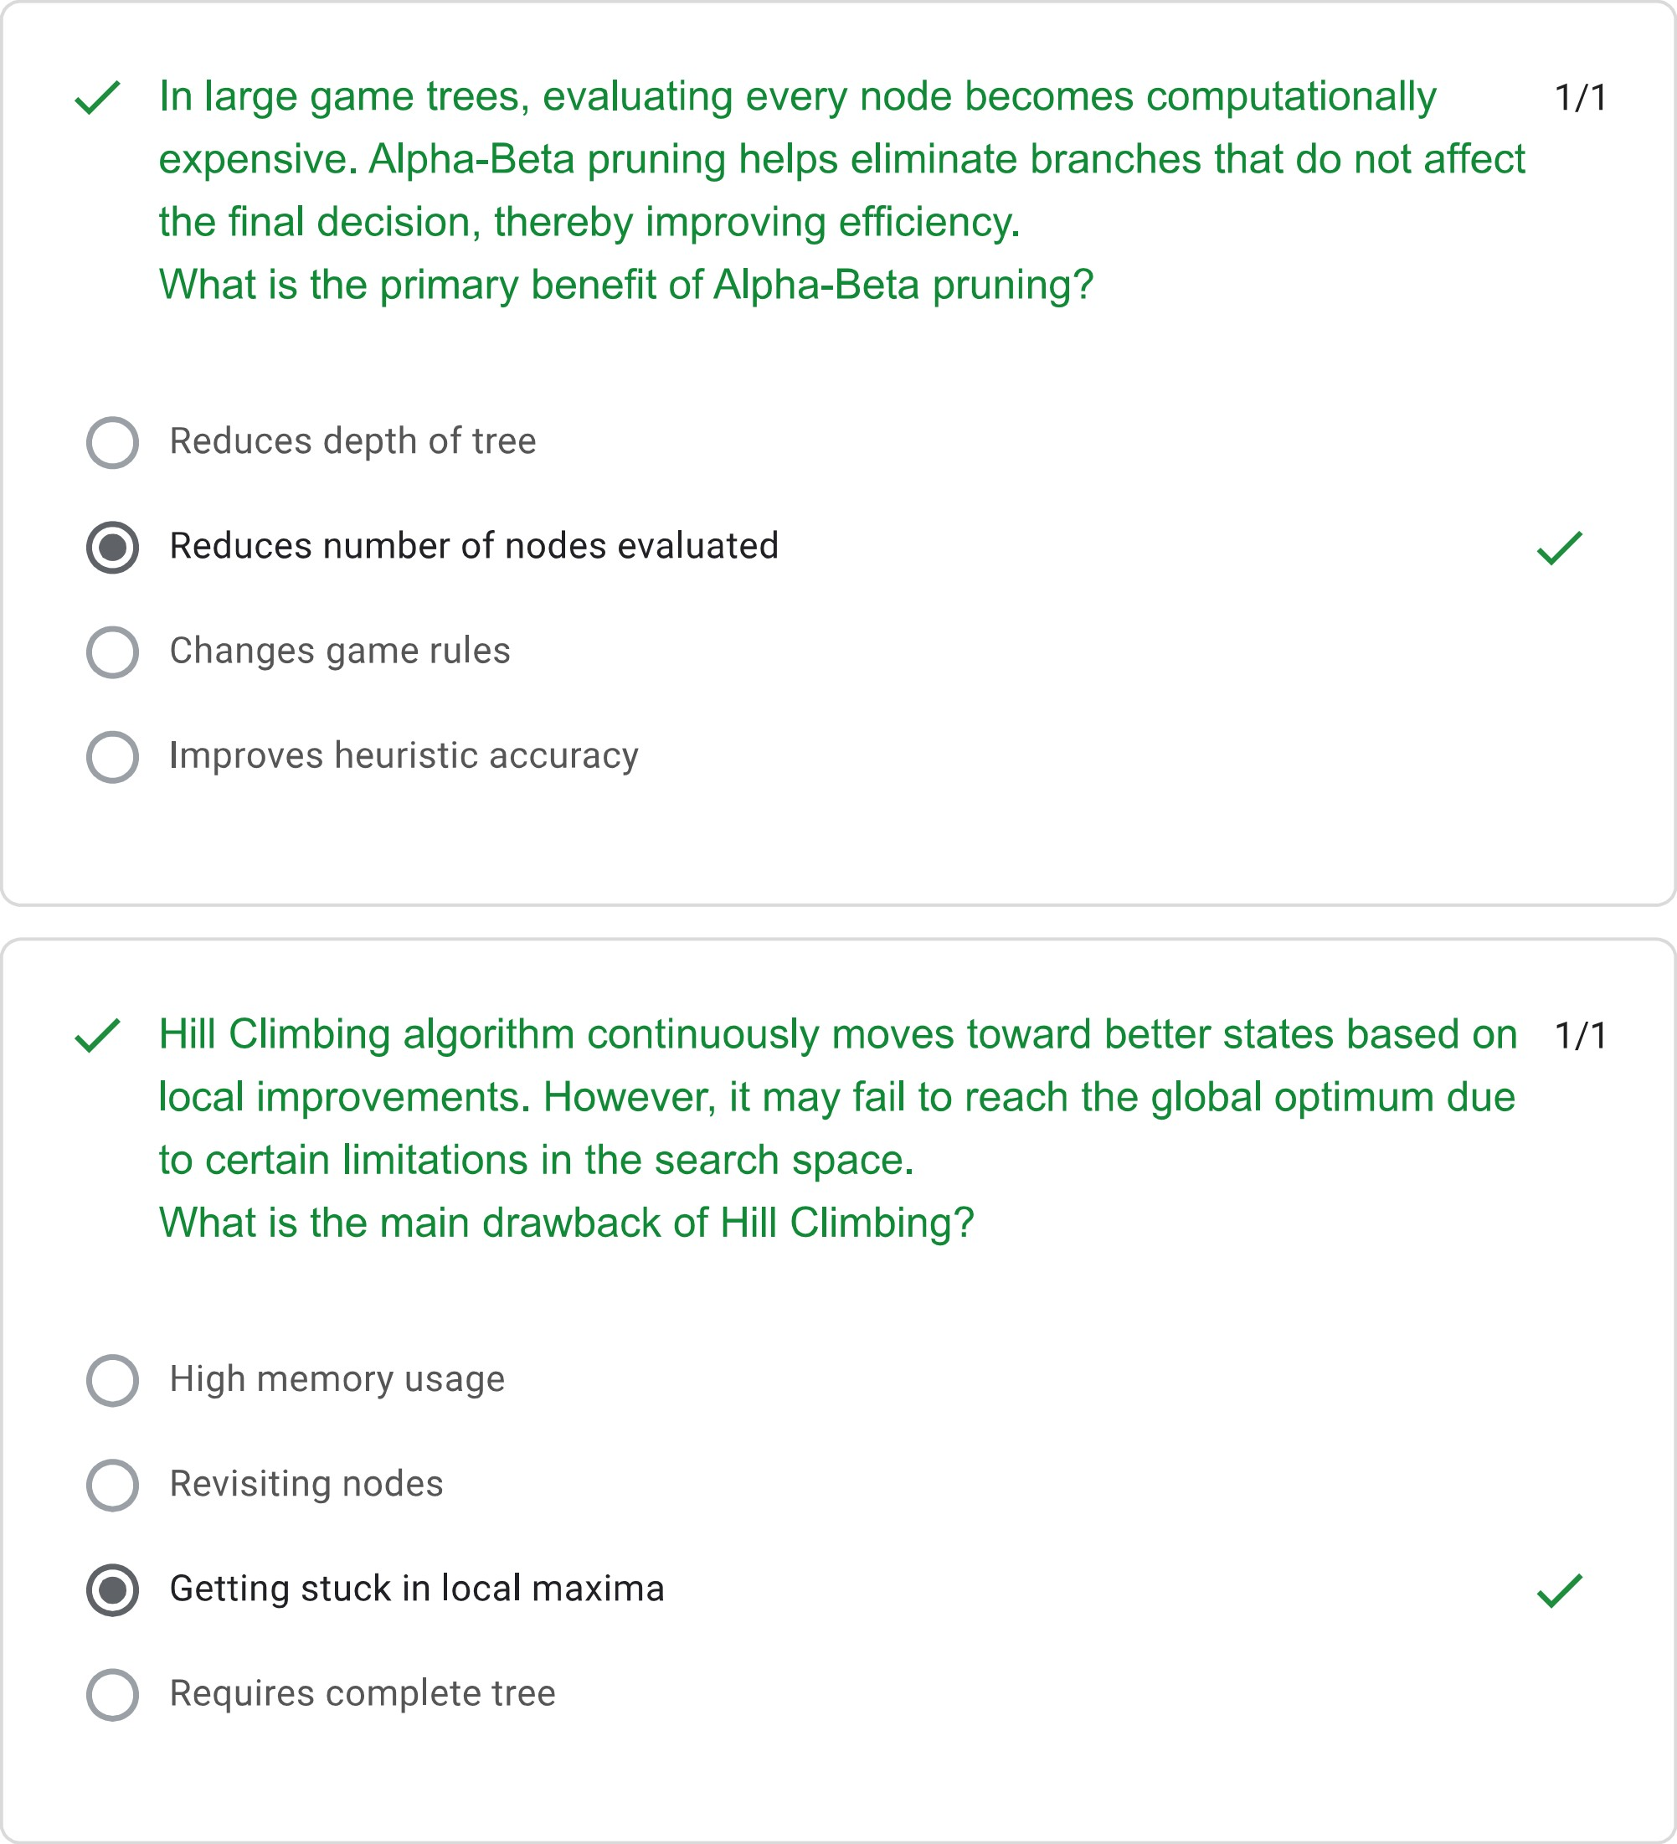
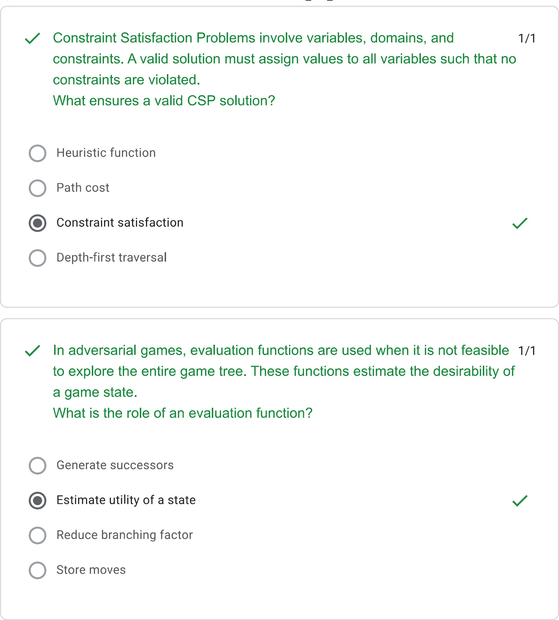
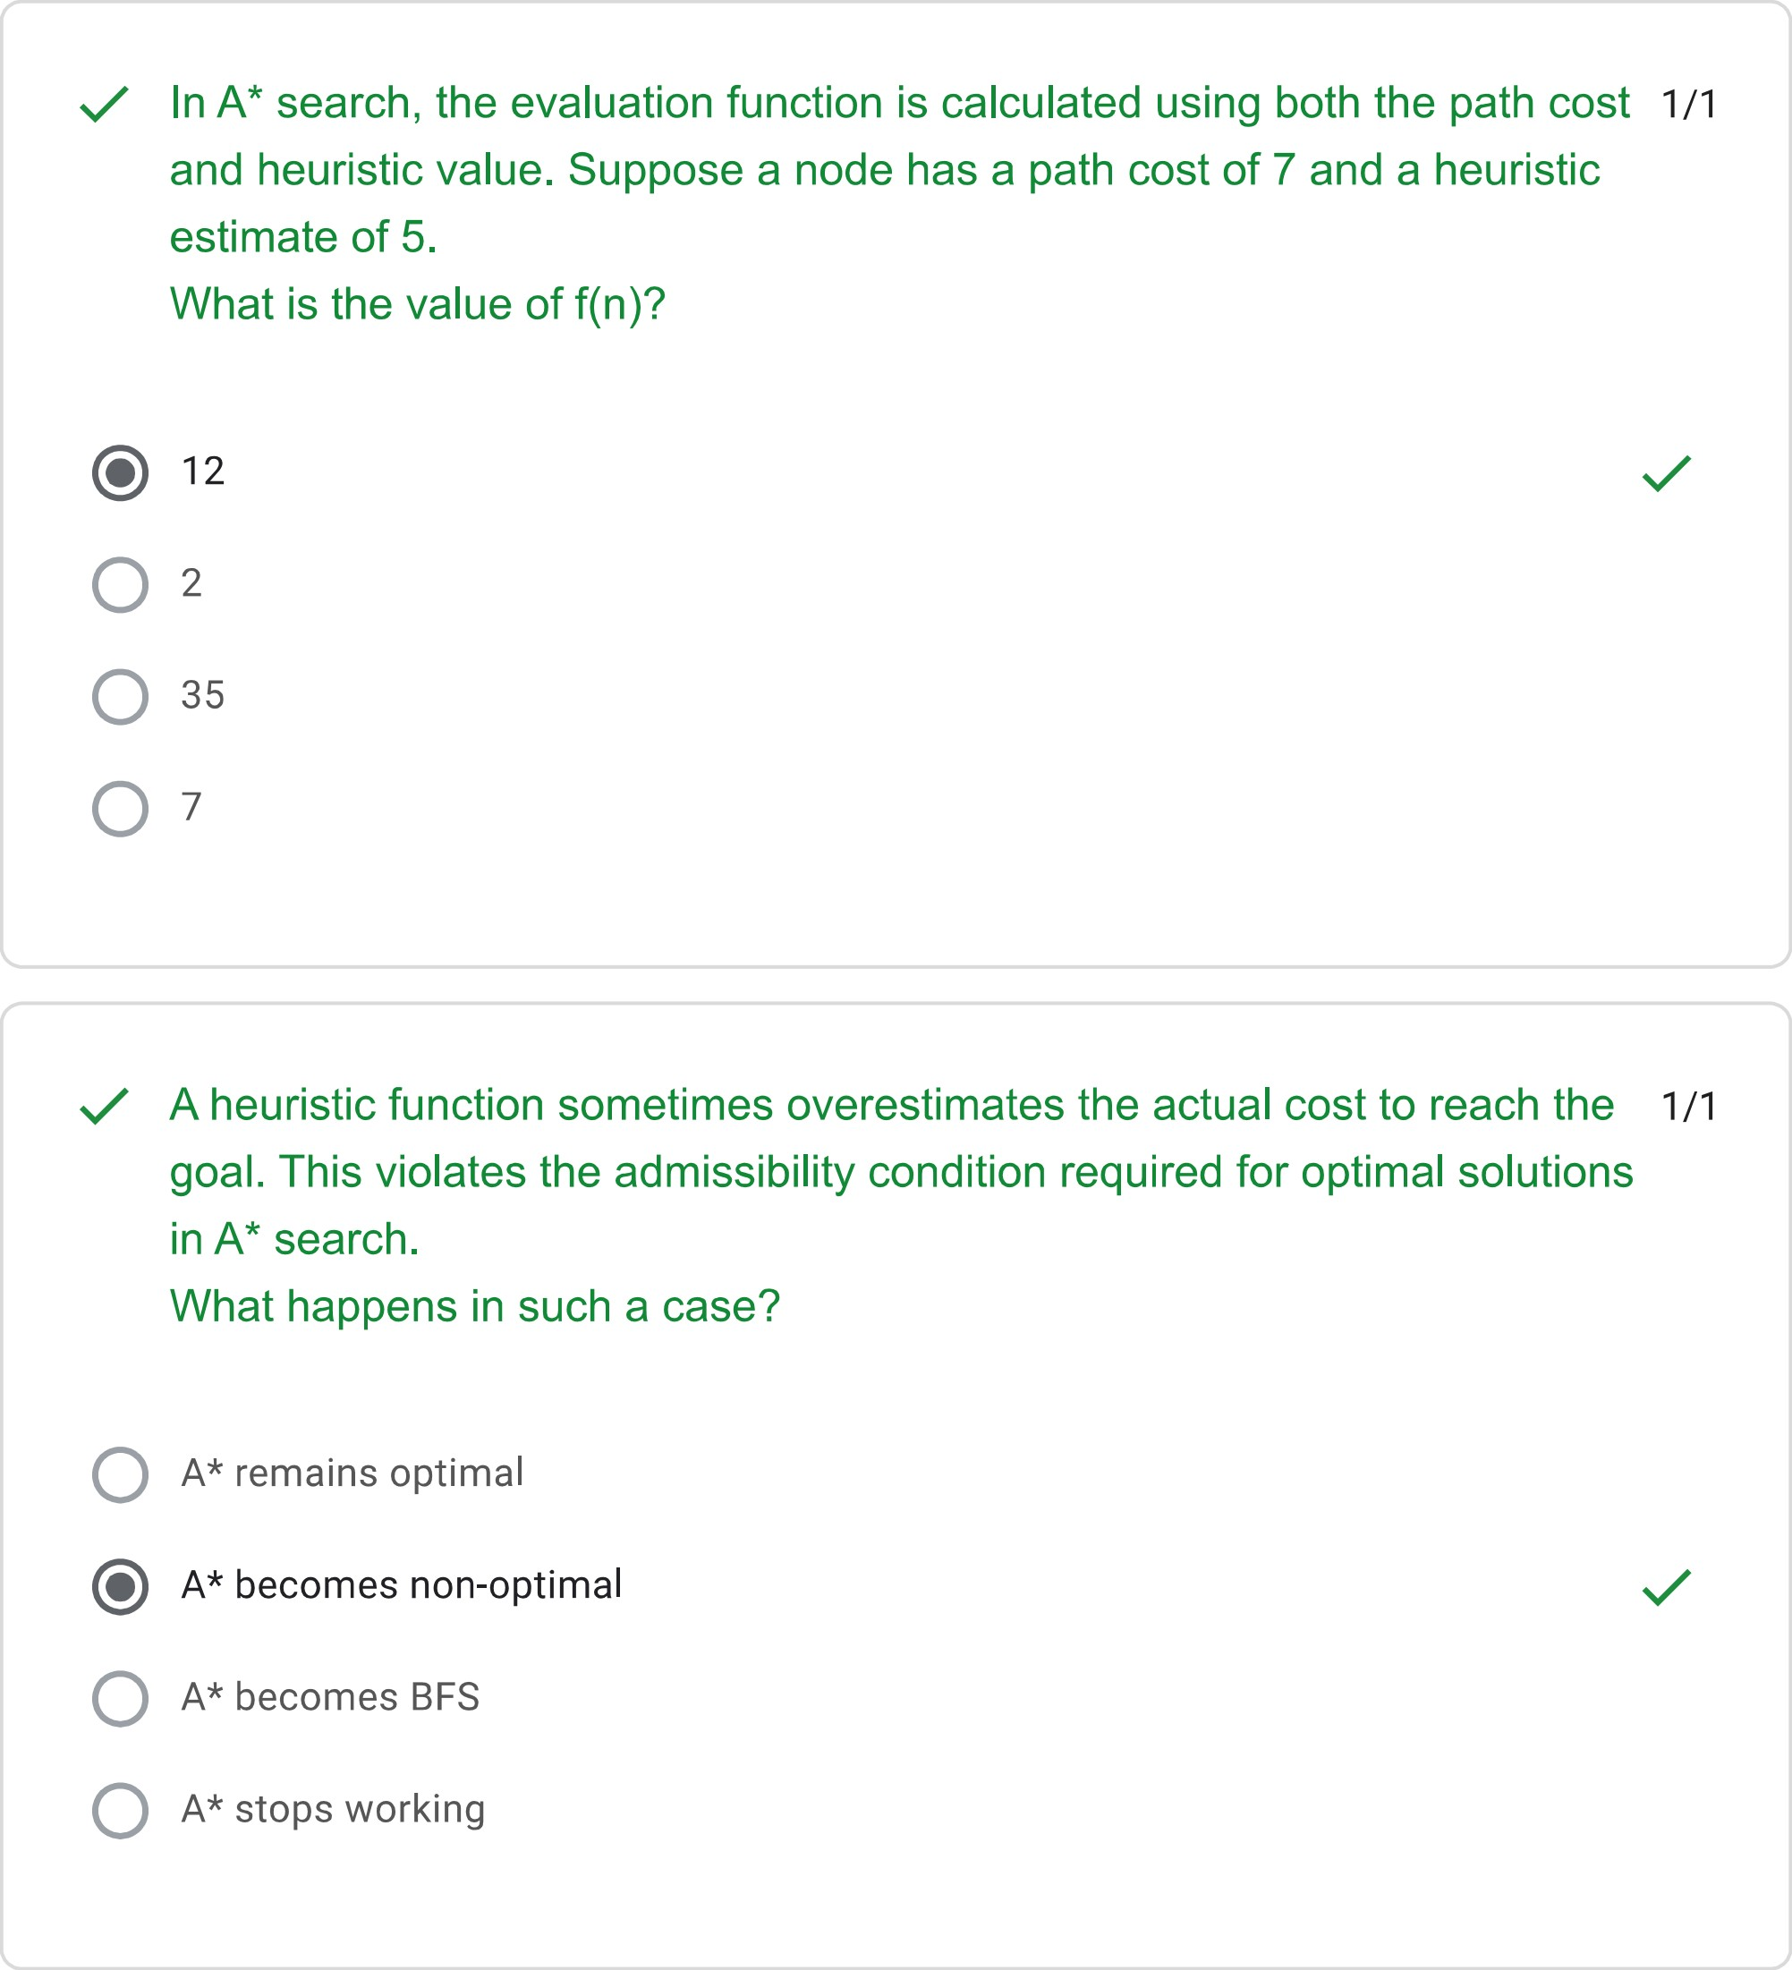
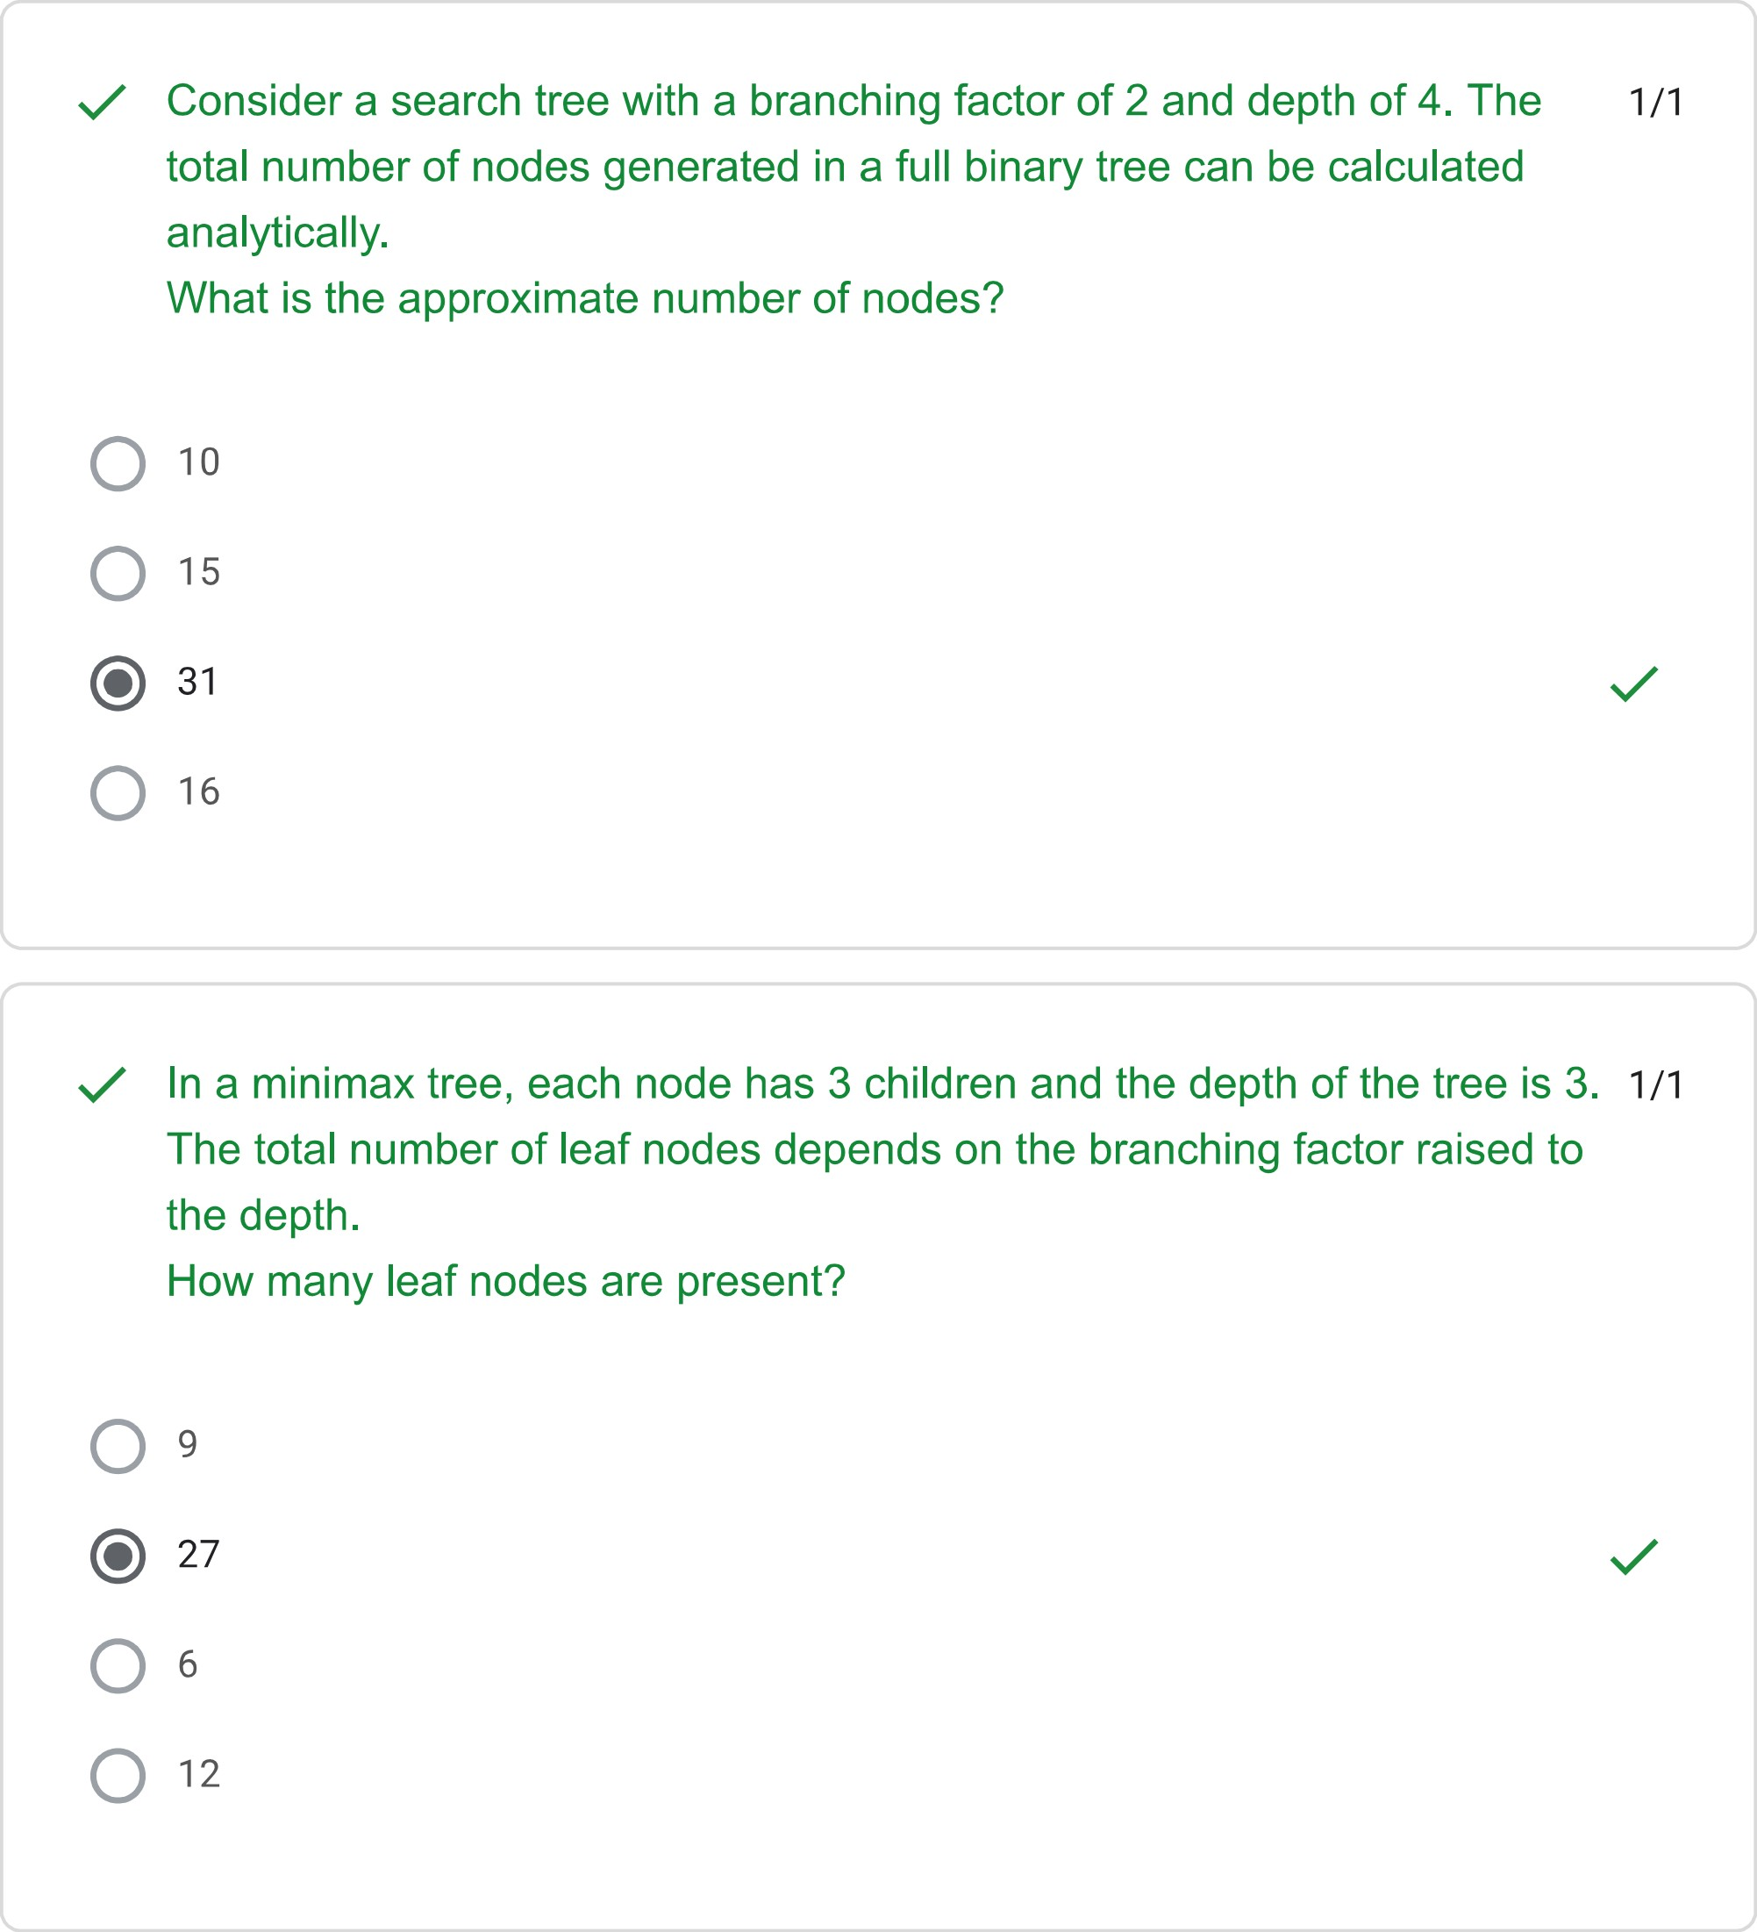

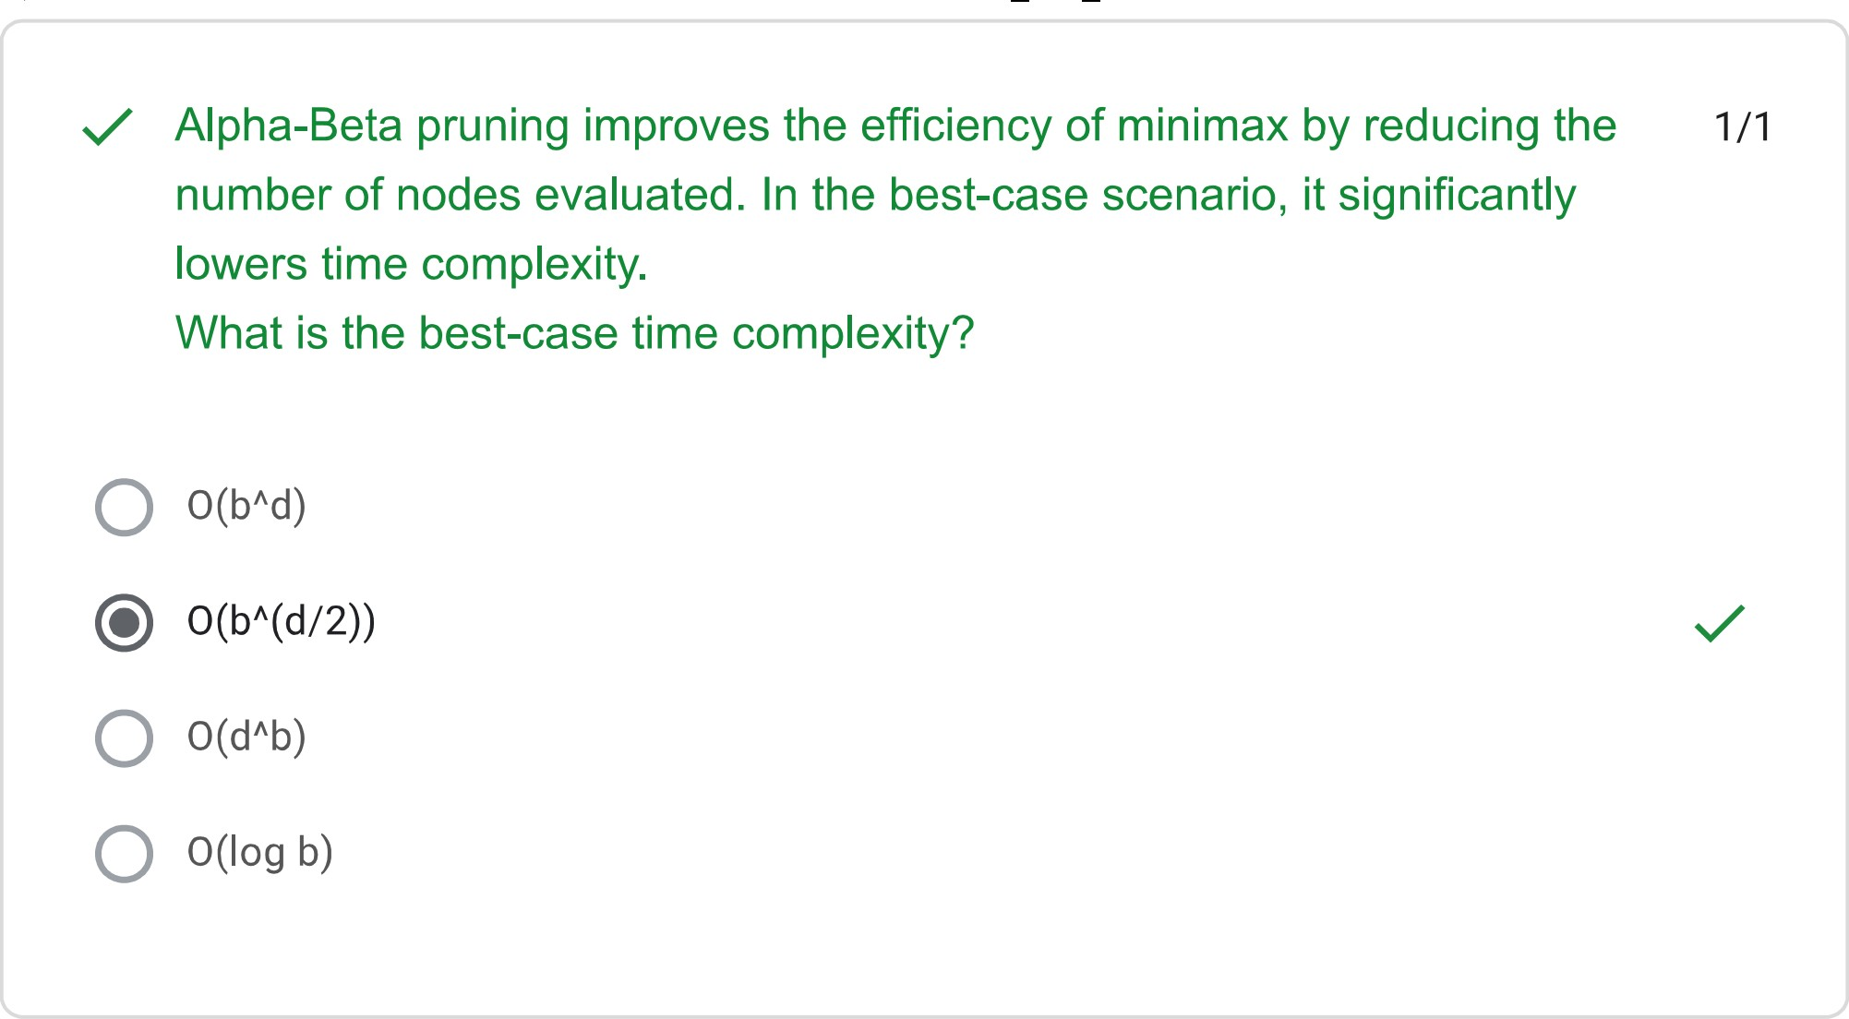
This form was created inside of Saveetha Institute of Medical and Technical Sciences. - Contact form owner
Does this form look suspicious? Report
Google Forms

